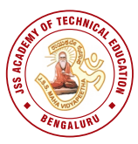
JSS MAHAVIDYAPEETHA
JSS ACADEMY OF TECHNICAL EDUCATION
Affiliated to Visvesvaraya Technological University, Belagavi, Karnataka, INDIA
Approved by All India Council for Technical Education, New Delhi
UG programs accredited by NBA: CIVIL,CSE, ECE, E&IE, ISE, IEM & MECHANICAL ENGG.

Date: 03.07.2021

REPORT OF THE JSS ACADEMY OF TECHNICAL EDUCATION ALUMNI ASSOCIATION IANGURAL FUNCTION
JSS Academy of Technical Education, Bangalore organized the inaugural function Alumni Associations inaugural function through virtual mode on 03rd July 2021 from 10:00AM to 01:00 PM.
The event started at 10.00AM with the warm invocation song by Ms Chaitra of 6th semester, E&IE Dept and the auspicious journey was followed by lighting the lamp in a virtual way.
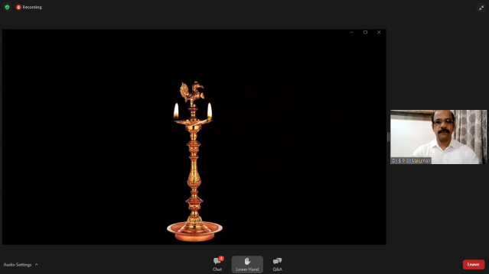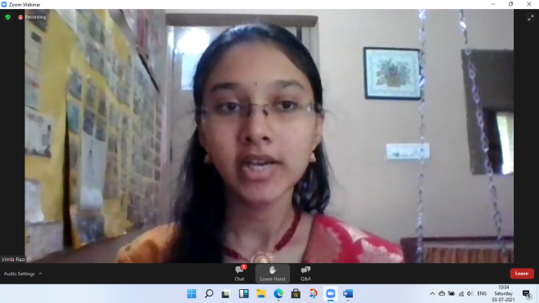
Dr. B.P.Shivakumar, Dean Student Welfare, JSSATE-Bengaluru, welcomed the whole gathering. Dr. Mrityunjaya V Latte, Principal, JSSATE-Bengaluru addressed all the chief guests, guest of honors, the president of JSSATEBAA and the alumni who were present in the meet. Then the first chief guest of the event N. Manjunatha Prasad, IAS, Principal Secretary, Revenue & Disaster Management, Government of Karnataka was introduced by Dr. D. Jayadevappa, Professor & Head, Dept. of E&IE and the chief guest inaugurated Alumni Association virtually, followed by the enlightening words of the speaker.
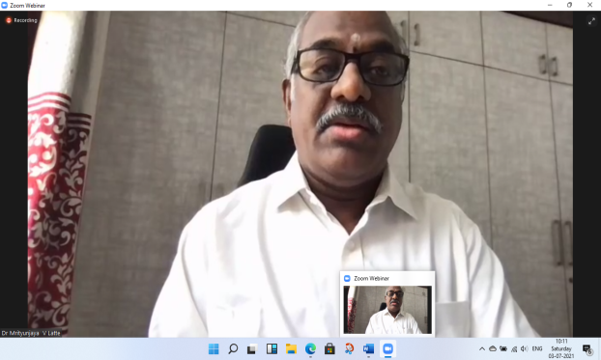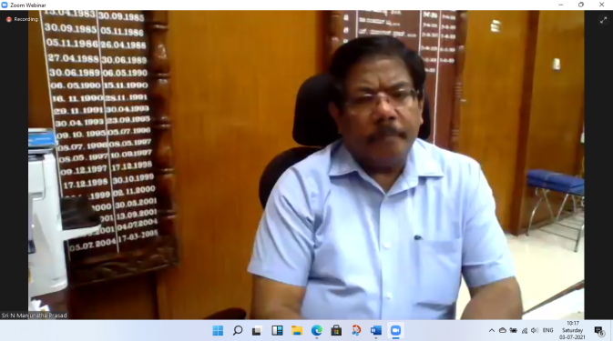
Dr C G Betsurmath, Executive Secretary, JSSMVP, Mysuru, the next chief guest of the event was introduced by Mrs. Snehalatha, Asst. Prof of Dept CSE. Sir has then inaugurated the website of Alumni Association followed by the inspiring words. Dr. Nagamani Purohit, Assistant Professor from Dept of ISE introduced the guest of honour Dr. H. R. Mahadevaswamy, Joint Director-TED, JSSMVP, Mysuru, Sir has then addressed the whole gathering by his suggestions and guidance and also inaugurated the logo of Alumni Association. The next guest of honour Mr Supreeth MG Senior Consultant, Talent Acquisition, M/s. Capgemini Technology Services was introduced by Mrs Chaya J Swamy asst prof dept of MBA. Mr Supreeth MG then felicitated the web designer Mr Rajath MR 6th sem ISE and our logo designer Ms Bhavani M 2nd sem MBA followed by addressing the gathering.
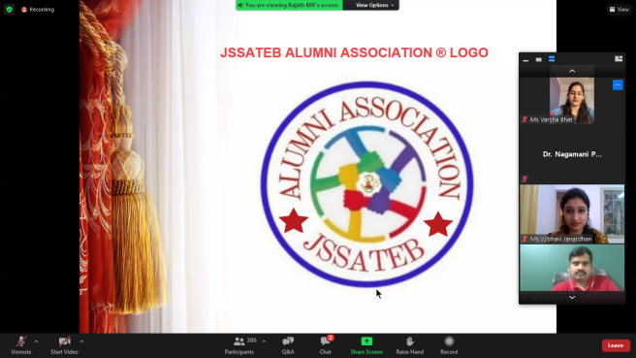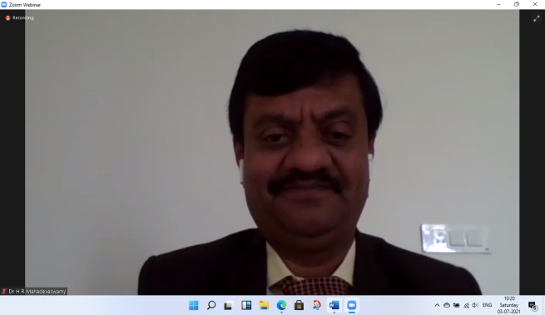
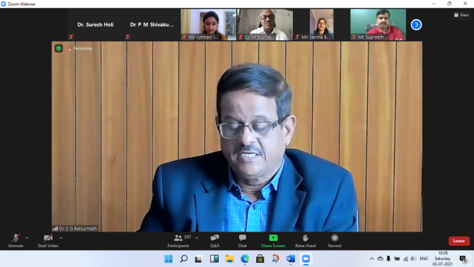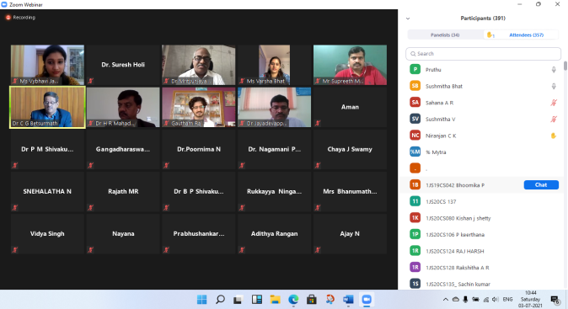
The event was then followed by the experience sharing session. Around 15 extinguished alumni from all the department have shared their 4 years of beautiful experience with the institute to all the participants.
Mr. Rajath, the website designer demonstrated the process of registration to be followed in the alumni association website.
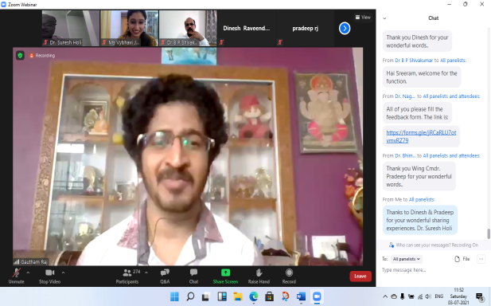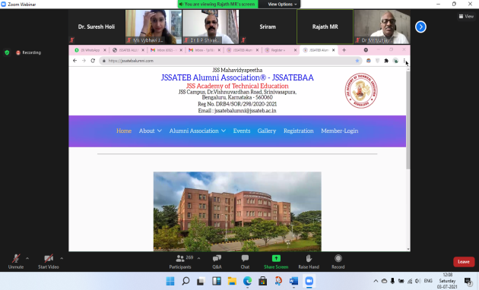
Then the session was followed with presidential speech by Mr Gireesh, President of JSSATEB Alumni Association. Dr. Thejaswini P. delivered the vote of thanks for all the guests, alumni, coordinators of the event and all other faculty members.
Finally the event was concluded with the entertaining cultural events by the students of various departments of the institute.
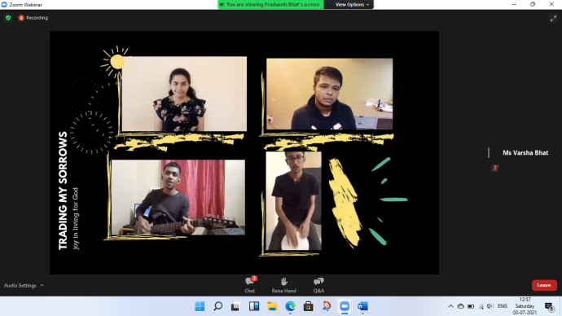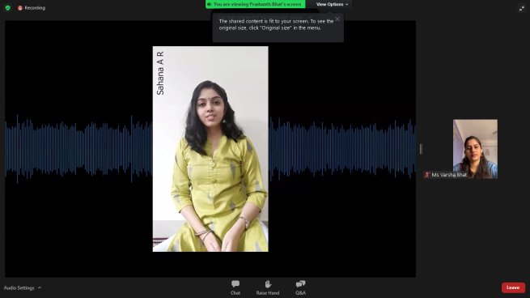
The whole event was smoothly carried throughout by Ms Vaibhavi and Ms Varsha’s (Alumni of JSSATEB) anchoring. And the institute is happy to convey that 259 alumni from various states and countries have registered and participated in the event.

Dr Mrityunjaya V Latte

PRINCIPAL

