JSS MAHAVIDYAPEETHA
JSS Academy of Technical Education,Bengaluru – 60
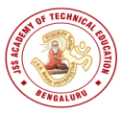
(Affiliated to VTU, Belagavi and Approved by AICTE, New Delhi)
Report on Global Alumni Meet -2k23
JSS Academy of Technical Education, Bengaluru had organised Global Alumni Meet-2k23 on 28th January, 2023 at its campus as part of its Silver Jubilee celebrations. The objective was to encourage, foster and promote close relations among the alumni.
The Distinguished Guests who graced the occasion were Chief Guest Ms.Veena Rajappa, Managing Director, Accenture and Mr.Vinay Patil, Leadership Coach, Founder & CEO-Skillfix, Founder & MD-Roots Education. The Guest of Honor was Dr.HR Mahadevaswamy,Joint Director-TED,JSSMVP,Mysuru,Dr.Bhimasen Soragaon,Principal-JSSATEB, Dr.P.M Shivakumarswamy Alumni Coordinator,Dr.D.Mahesh Kumar, Professor & Dean Student Welfare,Mr.Vinod ,Vice President,JSSATEB Alumni Association.
The program began with beautiful invocation song to seek the blessings of God by Ms.Shriraksha, 5th sem BE(ISE) Dr. Bhimasen Soragaon, Principal-JSSATEB addressed the gathering with “Shanti Mantra”. He also highlighted on Vision & Mission of JSSATEB.Light symbolizes knowledge, and darkness, ignorance. All the Dignitaries inaugurated Global Alumni Meet 2k23 by auspicious lighting the lamp.
The Chief Guest,Ms.Veena Rajappa,MD-Accenture addressed the Alumnus of JSSATE-B about importance of having sense of gratitude in life, networking, learning through conversations and significance of alumini meet. She also suggested that “keep passion alive no matter what happens, that is the way to lead a healthy life”Ms. Veena Rajappa was felicitated as a taken of gratitude by Dr.H.RMahadevaswamy,Joint Director-TED,JSSMVP,Mysuru and other dignitaries.
The 2nd Chief Guest for the day was Mr.Vinay Patil, Alumnus, BE(2009 batch) Leadership Coach, Founder & CEO,Skillfix,Founder & MD,Roots Education He expressed that Ultimate way to success is “Dream Big, Work on Achieving It”Mr.Vinay Patil was felicitated by our respected Principal, Dr.Bhimasen Soragaon and other dignitaries.
Dr. H R Mahadevaswamy, Joint Director-TED, JSSMVP, Mysuru in his address to gathering gave the Glimpse of JSS Mahavidyapeetha.He also stressed upon importance of Alumni staying connected with the college. He also congratulated each alumni for their successful life Dr.Bhimasen Soragaon, Principal-JSSATEB felicitated Dr.H R Mahadevaswamy,Joint Director-TED,JSSMVP,Mysuru.
Few Alumni shared their experiences and views on contribution of JSSATE-B college and faculty towards helping them mould their personality and career. They also gave suggestions on the importance of networking and also to support JSSATE-B in placements
Mr.Vinod Kumar, Vice President –JSSATE-Alumni Association addressed the Alumni by suggesting the gap between industry and academics could be bridged with the help of Alumni involvement and interaction. Lastly, he announced the 5 categories of alumni to be considered as distinguished Alumni Nominations from next year: 2024.
a) Category 1: Administrative b) Category 2: Corporate c) Category 3: Entrepreneurial d) Category 4: Social Science e) Category 5:Entertainment
The Alumni meet concluded with a Vote of Thanks delivered by Dr.Thejaswini P, Associate Professor, and Secretary-Alumni Association.
Later. Cultural events and games by students were arranged for the alumni and coordinated by Mrs.Roopa B, Assistant Professor, Mechanical Department.Lastly; Alumni interacted in their respective departments after lunch.
PHOTOS WITH CAPTION:
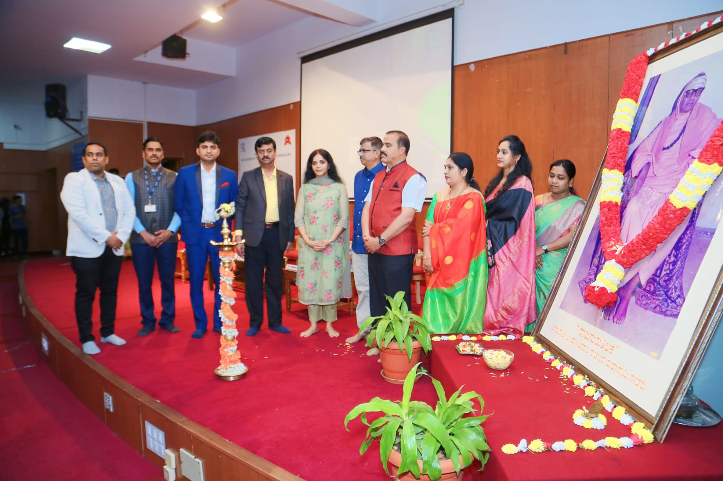
Auspicious Lamp Lighting Ceremony by the dignataries for Global Alumni Meet 2k23.
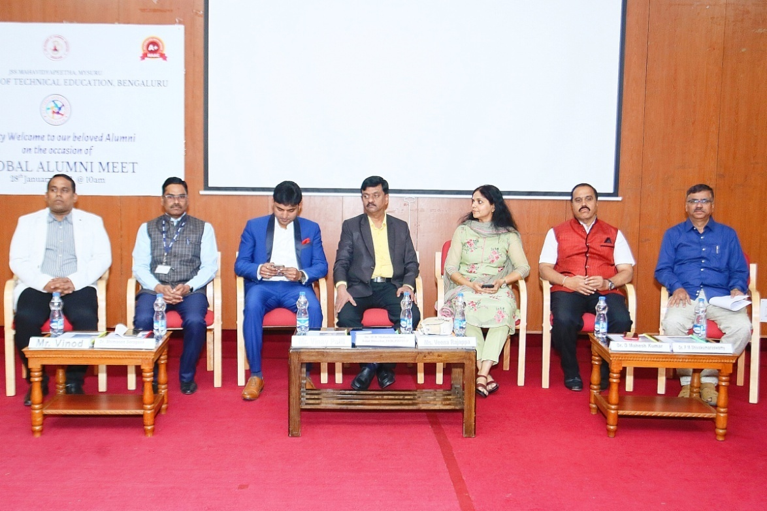
From Left:Mr.Vinod,Vice President,JSSATEB Alumni Association,Dr.Bhimasen Soragaon,Principal-JSSATEB,Chief Guest:Mr.Vinay Patil-Alumnus,Founder & CEO,Skillfix,Dr.H.R Mahadevaswamy,Joint Director,TED,JSSMVP,Mysuru,Chief Guest:Ms.Veena Rajappa,MD,Accenture,Dr.D.Maheshkumar-Professor & Dean-Student Welfare,Dr.P M Shivakumarswamy,HOD-EC,Institute Alumni Coordinator

