JSS Mahavidyapeetha
JSS Academy of Technical Education, Bengaluru-560060
Report on Global Alumni Meet 2025
JSS Academy of Technical Education, Bengaluru conducted its 3rd Global Alumni Meet inviting all its passed-out Engineering and Management students since last 3 decades on Saturday, 18th January 2025. The program commenced at 4pm with an invocation song by Sahana G.S of 3rd sem MBA and the guests were welcomed by Dr. D Mahesh Kumar D, Professor & Dean, Students Welfare. The chief guest for the occasion was IAS officer, Sri Darshan H.V, Director, Dept of Electronics, IT & BT, and Managing Director, KITS, Government of Karnataka and the Guests of Honour were Ms. Deepa Belankar, Group Manager, ADAS, Volvo GTT and Mr. Naveen Manjunath, India Lead – Campus Hiring, Tata Elxsi. Dr. B Suresh, Pro-Chancellor – JSS AHER & Director – TED, JSS Mahavidyapeetha, Mysuru conveyed best wishes to all the alumni on the occasion.
An alumna of CSE department - Ms Deepa Belankar, shared her experience of college days and emphasized on the importance of networking among the students for a successful career. She also urged the students to make the best use of the modern-day technology to boost their professional upliftment. Mr. Naveen, MBA alumna recalled his memories and praised the information technology for easing the problems of students and the employees. He highlighted the importance of honing advanced skills and adapting to the changes in the technology.
Dr. Bhimasen Soragaon, Principal, JSSATEB delivered presidential address expressing his happiness and gratitude for the gracious presence of our highly esteemed alumni on the occasion. The programme witnessed the presence of its distinguished alumni drawn from all parts of India who cherished nostalgic memories of meeting their long-term friends at the Institute. A report on Alumni activities conducted during the year at the Institute was presented by Dr. Tejaswini P, Associate Professor, and Dr. P.M Shivakumarswamy, Professor & Alumni Coordinator delivered Vote of Thanks concluding the inauguration session. Cultural events and light music were also organized followed by Dinner for the alumni of JSSATE, Bengaluru.
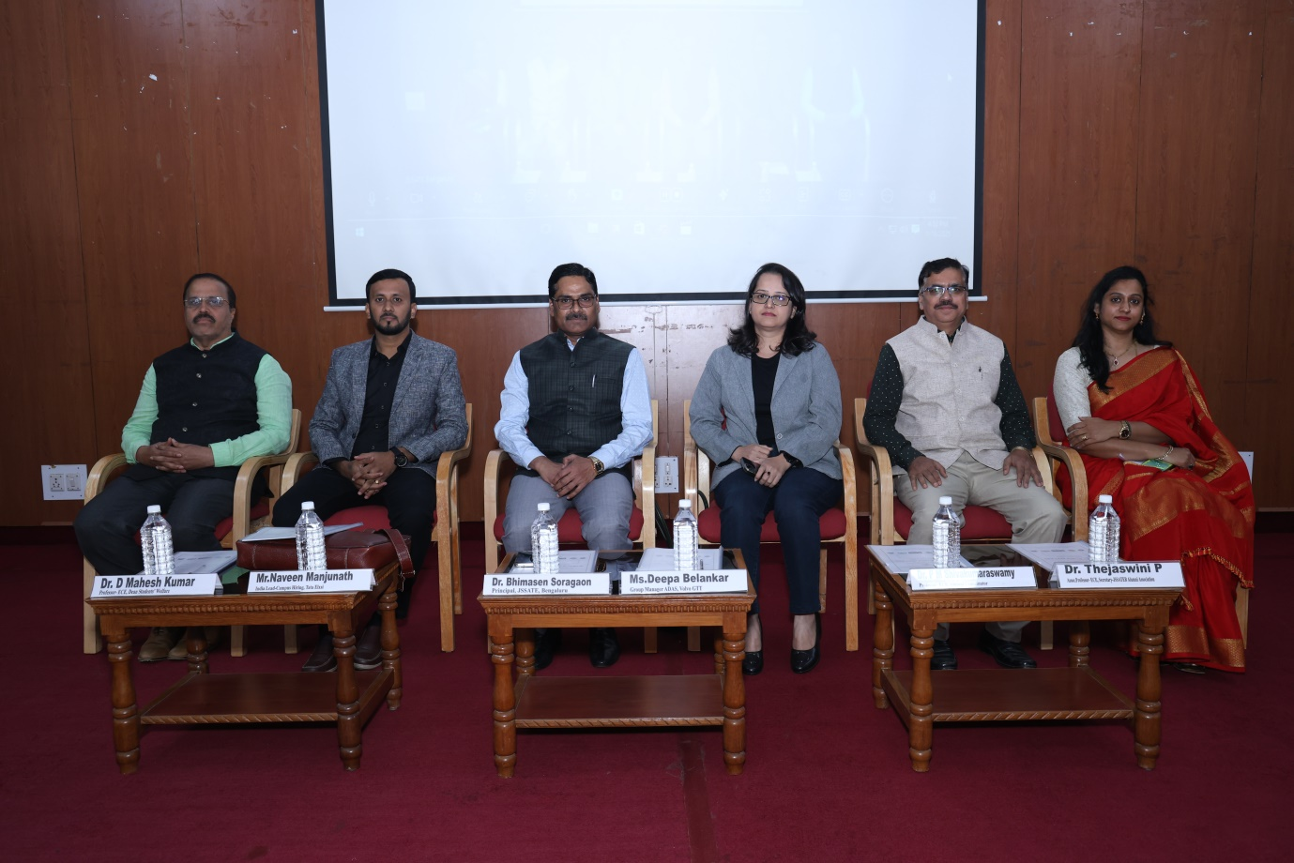
From left to right: Dr. D Mahesh Kumar, Dean Student Welfare, Mr Naveen, India Lead (Campus Hiring) – Tata Elxsi, Dr Bhimasen Soragoan, Principal, JSSATEB, Ms Deepa Belankar – Group Manager, Volvo GTT, Dr. P M Shivakumaraswamy, Alumni Coordinator, Dr. Thejaswini P, Secretary, JSSATEB Alumni Association
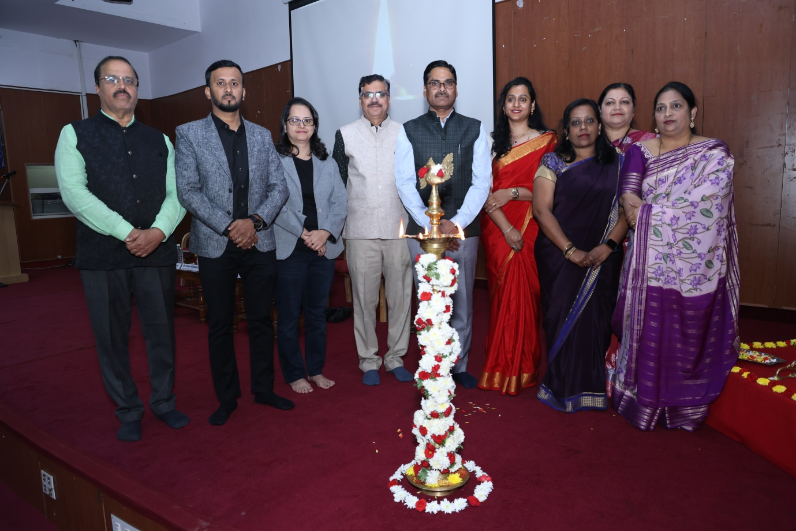
The dignitaries inaugurating the Global Alumni Meet 2025 by lighting lamp and seeking the blessings of His Holiness.
Photo Gallery:
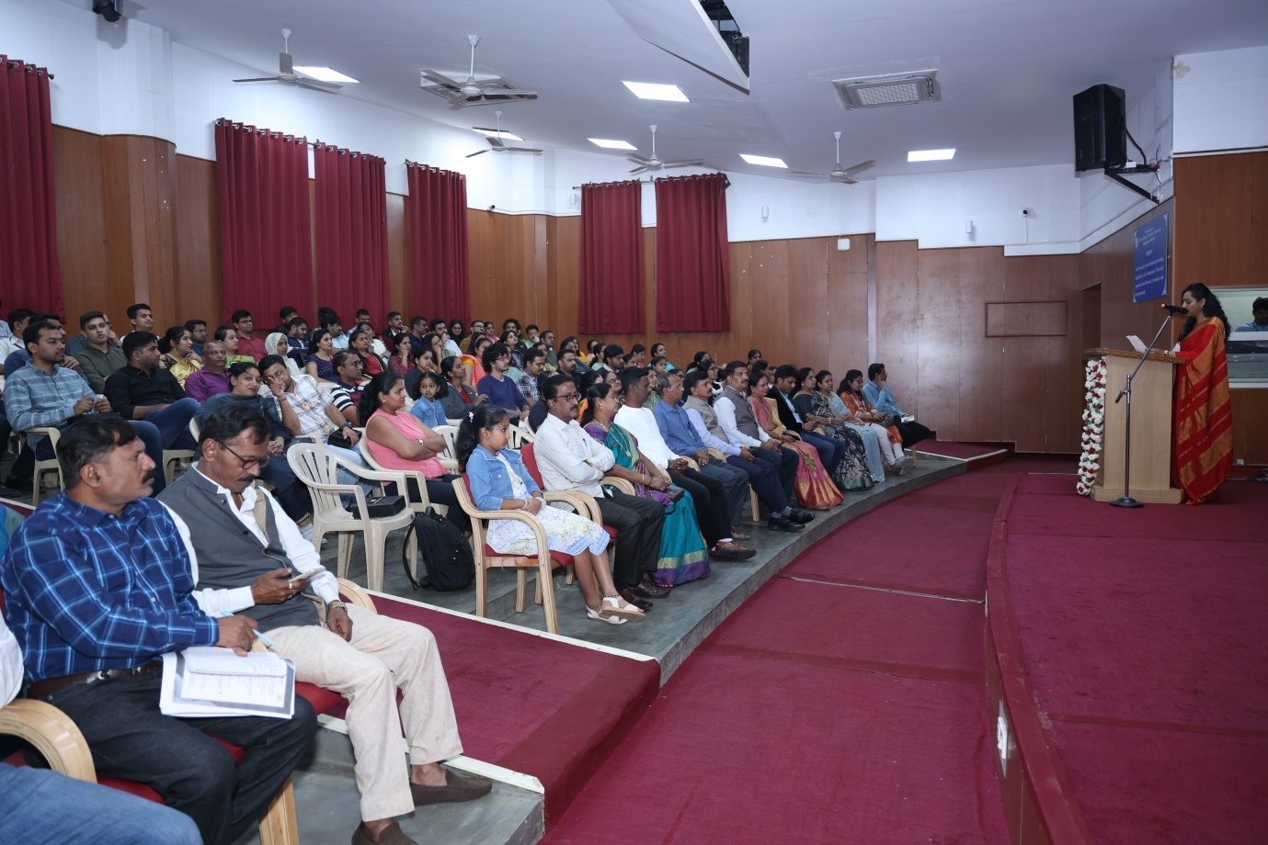
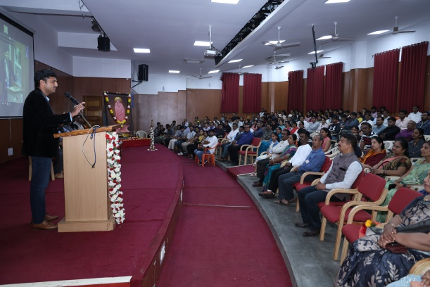 | 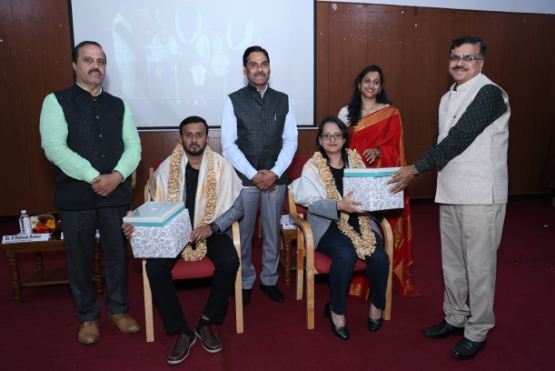
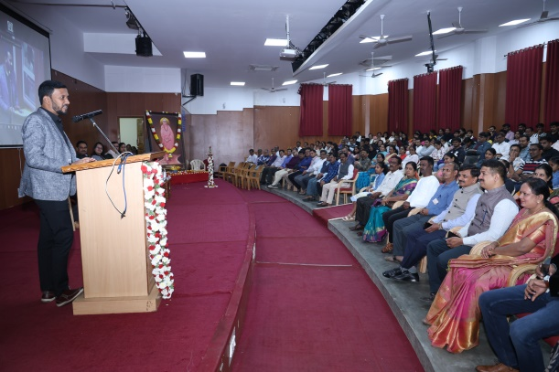 | 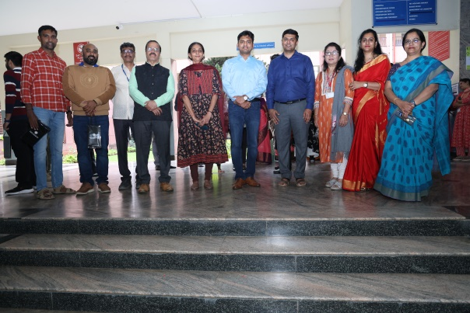
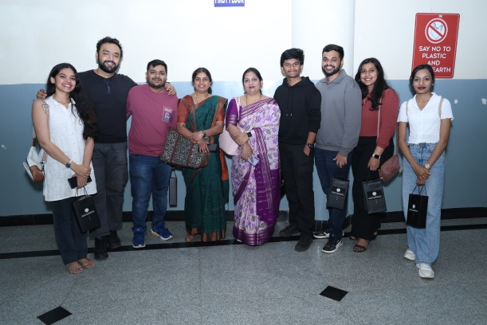 | 