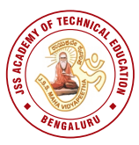 | JSS MAHAVIDYAPEETHA  JSS Academy of Technical Education, Bengaluru – 60
Report on Global Alumni Meet 2026
“An institution’s true strength is measured not by its buildings, but by the achievements and commitment of its alumni” and “When alumni stay connected, institutions grow stronger, wiser, and more meaningful.”

With the above motive, the entire campus of JSSATE, Bengaluru was beautifully decked up, illuminated with colourful lights, thematic props and a magnificent digital stage was set to welcome our esteemed alumni on Saturday, 31st January 2026 at 5 pm.
JSS Academy of Technical Education, Bengaluru organized the Global Alumni Meet–2026 on 31st January 2026 with the objective of strengthening alumni–institute relations and fostering knowledge sharing, career guidance, mentorship and collaboration for student and institutional development.
This time college had organised variety of indoor and outdoor games, including table tennis (singles and doubles), football, basketball, kabaddi, chess, treasure hunt, and carrom, between alumni and present students of JSSATEB. The events commenced at 1:00 PM and encouraged sportsmanship, teamwork, and alumni–student interaction.
The programme commenced at 6:00 PM with the splendid Bharatanatyam dance performance by Sindhoora and team welcoming all the invitees to Global Alumni Meet–2026 setting the right ambience for all the invitees for the occasion with the Master of Ceremony led by Ms. Sravanthi, and Mr. Karthik Iyer of JSSATEB.
The distinguished guests who graced the occasion included Dr. B. Suresh, Pro-Chancellor, JSSAHER and Director-TED, JSS Mahavidyapeetha, Mysuru, as the Chief Guest. The Guests of Honour were Ms. Vijayalakshmi Kashyap, Technical Director, Robert Bosch, and Mr. Venkat Raghav, Partner, IBM.The event was further honored by the presence of Dr. Bhimasen Soragon, Principal, JSSATEB; Sri Veeresh C. S., Administrative Officer, JSSATEB, Mr. Vinay S. Patil, President, JSSATEB Alumni Association, Dr. D. Mahesh Kumar, Professor and Dean, Student Welfare, Dr. P. M. Shivakumarswamy, Alumni Coordinator, and Dr. Thejaswini P, Secretary, Alumni Association, JSSATEB.
Dr. Thejaswini P, Secretary, Alumni Association, JSSATEB welcomed the dignitaries on the Dias and the audience.
Presidential address by: Dr Bhimasen Soragaon, Principal, JSSATEB: Sir emphasized that the strength of an institution today is not measured solely by admissions, infrastructure, rankings, or placements, but by the vitality and engagement of its alumni ecosystem, highlighting the critical role alumni play in shaping the institution’s growth and impact. Sir expressed his vision for active alumni involvement in mentorship and career guidance, industry–academia collaboration, research, innovations, startups, and institutional development through intellectuals and contributions.
Address by Chief Guest: Dr. B. Suresh, Pro-Chancellor, JSSAHER and Director-TED, JSS Mahavidyapeetha, Mysuru.
Sir started his talk with launching of Nano satellites in month May or June 2026 in collaboration with ISRO for studying the stability of drugs in space. Addressing the alumni sir highlighted the critical role of alumni, emphasizing that intellectual contributions, such as sharing knowledge and expertise to enhance research, teaching, and laboratories, are more impactful than financial donations. Sir suggested alumni to support and uplift each other and concluded his talk comparing the enduring relationship between Institution and their alma mater to that of a temple and devotee.
Address by Guest of Honour: Ms. Vijayalakshmi Kashyap, Technical Director, Robert Bosch,
Madam highlighted India’s rapid economic growth and emerging global technology leadership and progress is driven not by recession but by a major transformation powered by technology, particularly AI. She emphasized the critical role of academia in equipping students with the skills required to meet evolving industry demands. Madam pointed out that the disconnection between college education and industry requirements can only be bridged through active collaboration between academia and industry. In conclusion, she reaffirmed her commitment to working hand in hand with the institution to prepare the next generation of engineers for a rapidly transforming technological landscape driven by AI and domain expertise.
Address by Guest of Honour : Mr. Venkat Raghav, Partner, IBM
Sir nostalgically reflected on the institution’s early days, when the campus comprised a single building surrounded by muddy access. Sir expressed immense pride in JSSATEB’s remarkable growth over the years and acknowledged the contributions of Management, faculty members, alumni, and students in shaping the institution’s progress. He concluded by stating that he felt proud to have played a small part in this remarkable journey.
Followed by distribution of trophies to the sports winner by the esteemed dignitaries.
Address by Mr. Vinay S. Patil, President, JSSATEB Alumni Association
The address provided a brief overview of the JSSATB Alumni Association, which was formed on 10 February 2021 and officially inaugurated on 3 July 2021. The Global Alumni meet been held annually since 2022.
He said he is Looking ahead for:
• Scheduling future Global Alumni Meets in December to improve overseas participation.
• Organizing international alumni meets, starting with the US, to strengthen global outreach.
• Using the AlmaShine platform to centralize alumni data and improve connectivity.
• Expanding student engagement programs, including startup, AI, and innovation summits.
He concluded with a call, to dream big, collaborate actively, and collectively build a vibrant, impactful alumni community.
Vote of thanks by: Dr. P. M. Shivakumarswamy, Alumni Coordinator, On behalf of the institution and the alumni fraternity, extended heartfelt gratitude to everyone who contributed to the grand success of the Global Alumni Meet 2026.
The event was then continued with Cultural Events like Dance, Fashion show etc. followed by Moon light dinner.
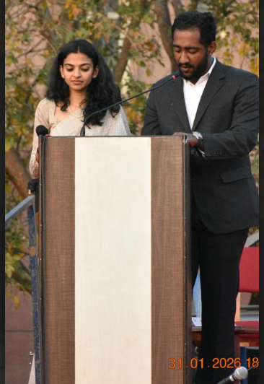

Global Alumni Meet 2026: Master of Ceremony by Ms.Sravanthi & Mr. Karthik Iyer

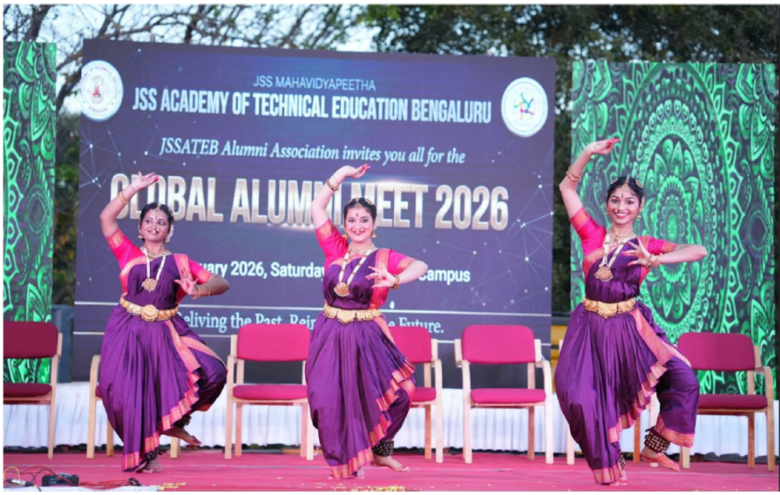
Classical Welcome Dance by Ms. Sindoora and Team

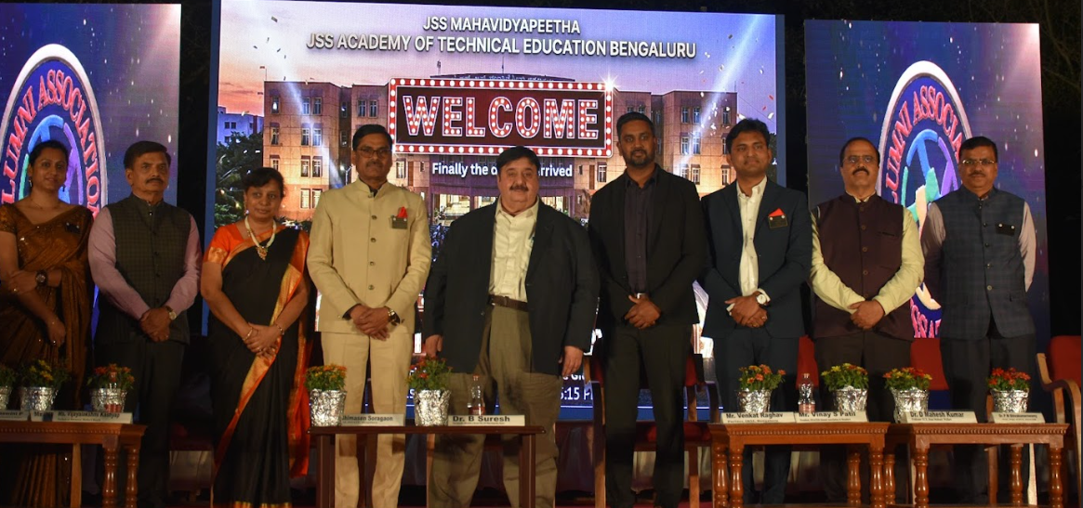
From left to right: Dr. Thejaswini P, Secretary, JSSATEB, Sri. Veeresh C S, Administrative Officer, JSSATEB, Ms. Vijayalakshmi Kashyap, Technical Director Robert Bosch, Dr Bhimasen Soragaon, Principal, JSSATEB, Dr. B Suresh Pro-Chancellor, JSSAHER Director-TED, JSS Mahavidyapeetha, Mysuru, Mr. Venkat Raghav, Partner IBM, Mr. Vinay S Patil, President,JSSATEB Alumni Association & Member, Dr. D Mahesh Kumar, Dean Student Welfare, Dr. P M Shivakumaraswamy, Institute Alumni Coordinator, JSSATEB.

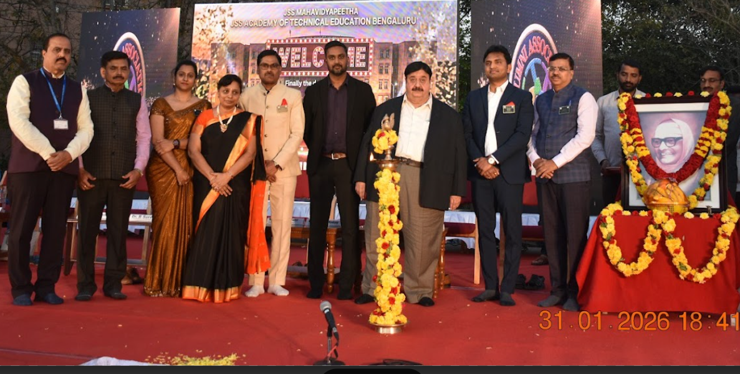
Inaugural lamp lighting by the esteemed dignitaries.

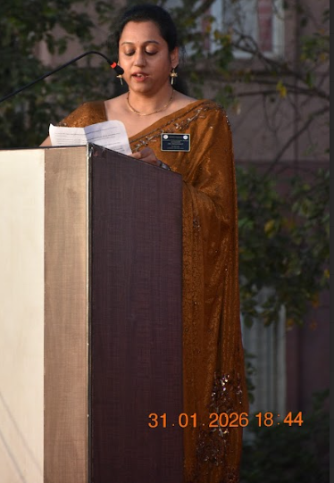 | 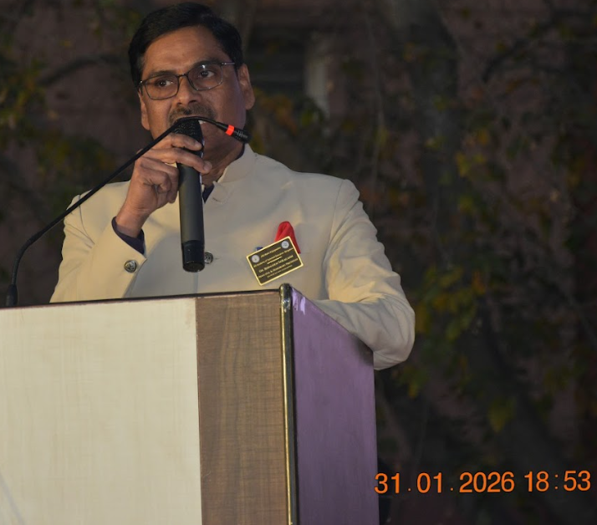
Welcome address : Dr. Thejaswini P, JSSATEB. | Presidential address: Dr Bhimasen Soragaon, Principal.
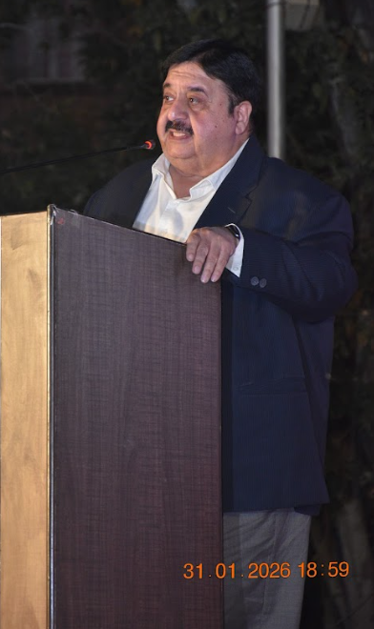 | 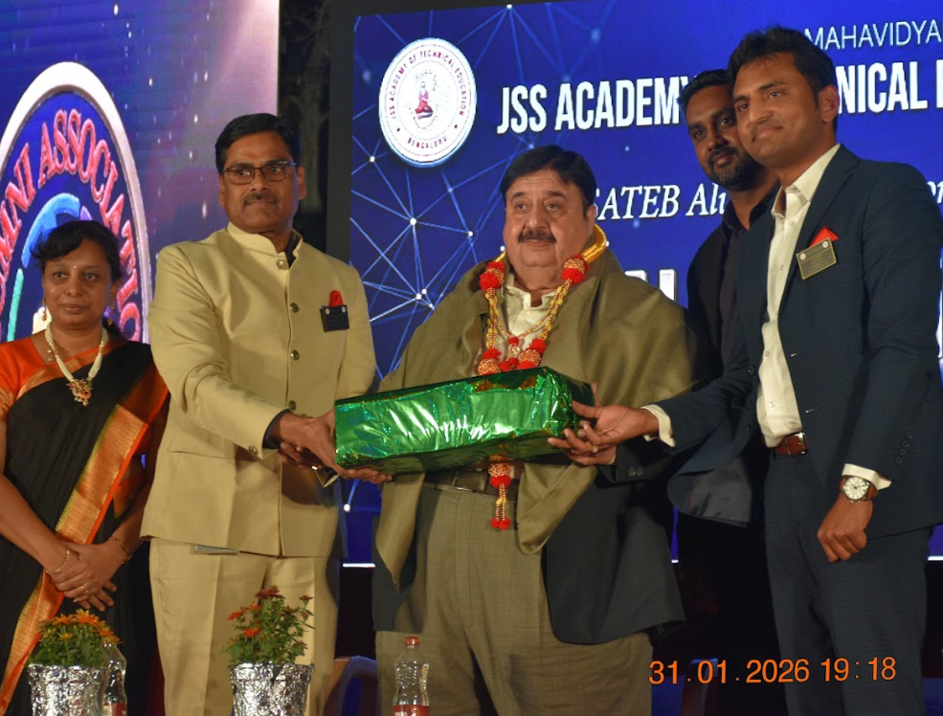
Chief Guest: Dr. B Suresh Pro-Chancellor, JSSAHER Director-TED, JSSMVP,Mysuru addressing the gathering | Felicitaion of chief guest Dr. B Suresh by Principal
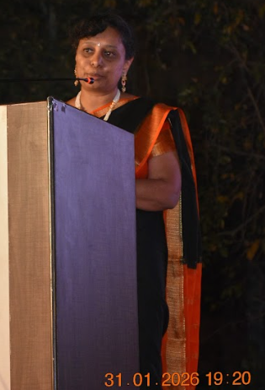 | 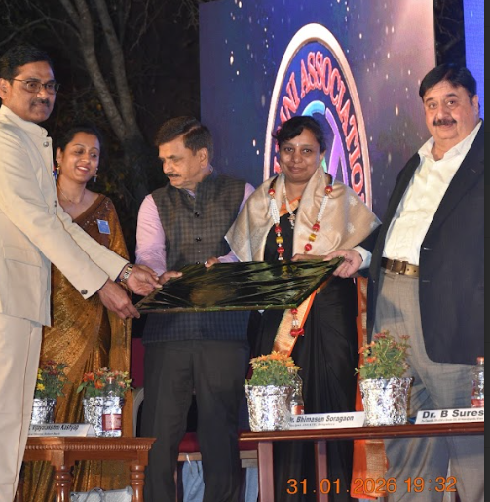
Guest of honour Ms. Vijayalakshmi Kashyap Technical Director Robert Bosch Adressing the gathering | Felicitaion of Ms. Vijayalakshmi Kashyap by esteemed dignitaries
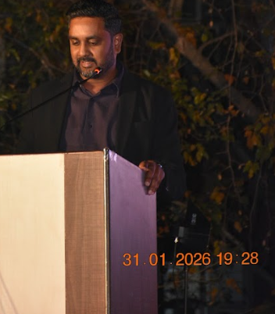 | 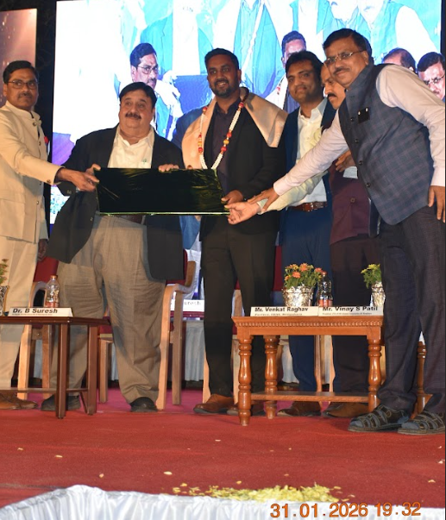
Guest of honour Mr. Venkat Raghav, Partner IBM Adressing the gathering | Felicitaion of Mr. Venkat Raghav by esteemed dignitaries
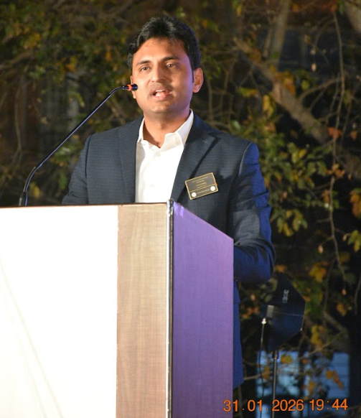 | 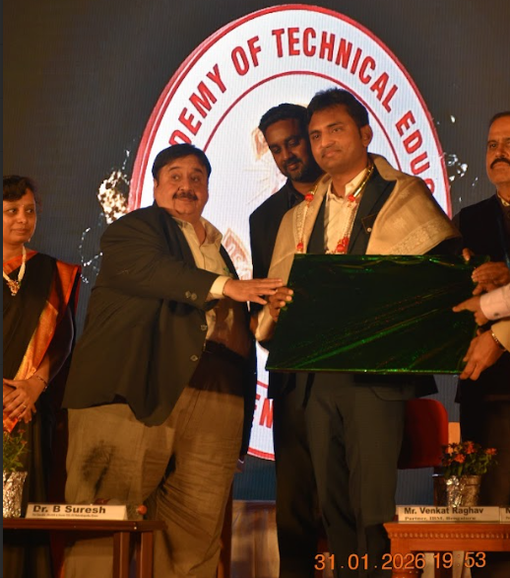
Mr. Vinay S Patil, Adressing the gathering | Felicitaion of Mr. Vinay S Patil by esteemed dignitaries
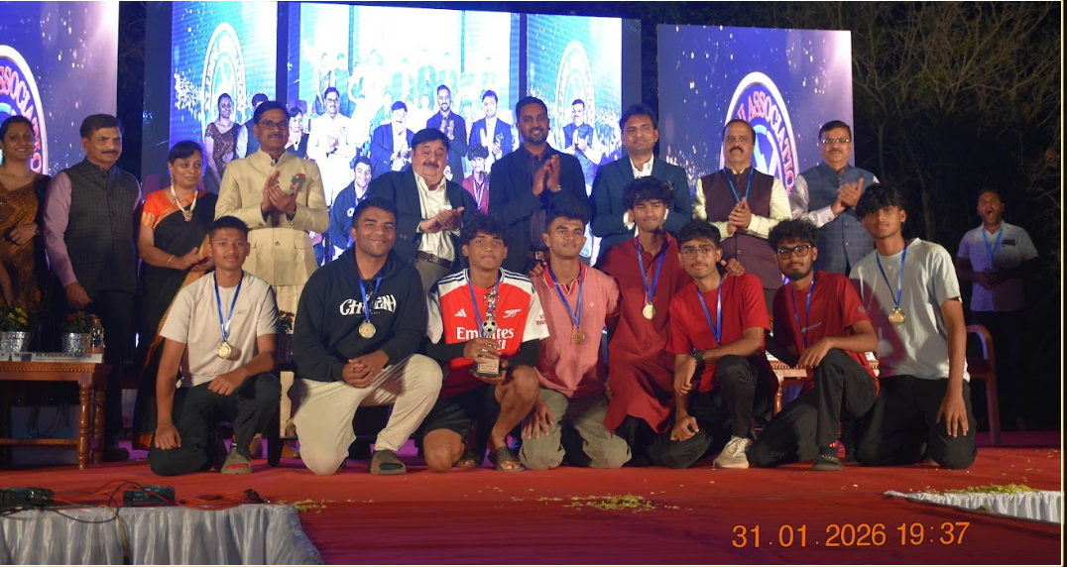
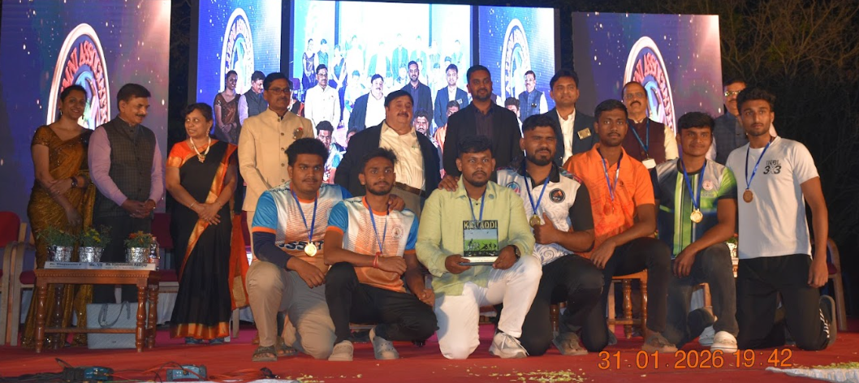
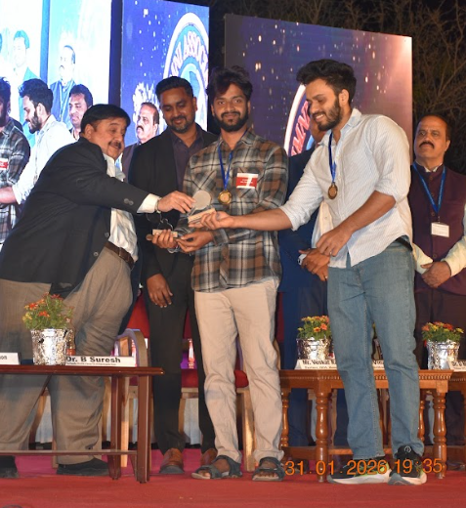 | 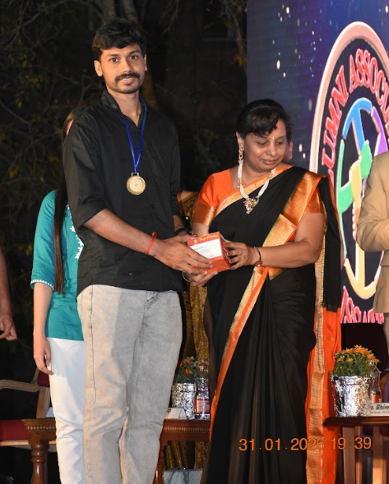
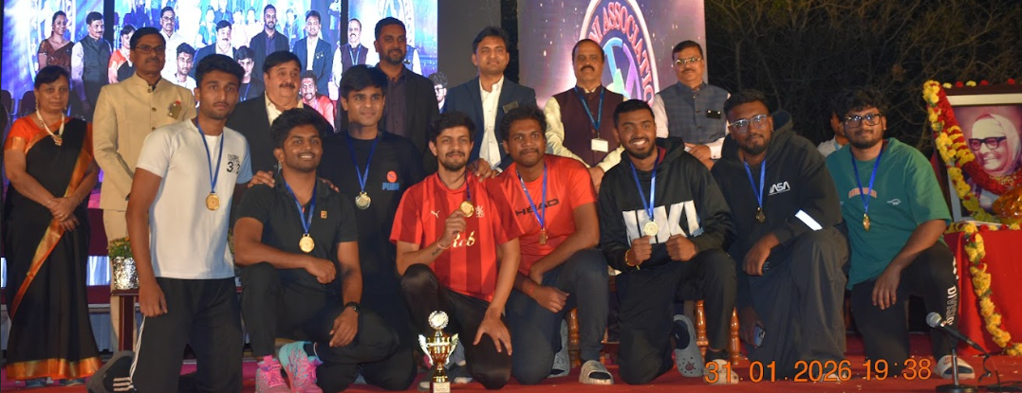
Prize distribution to the Sports winners

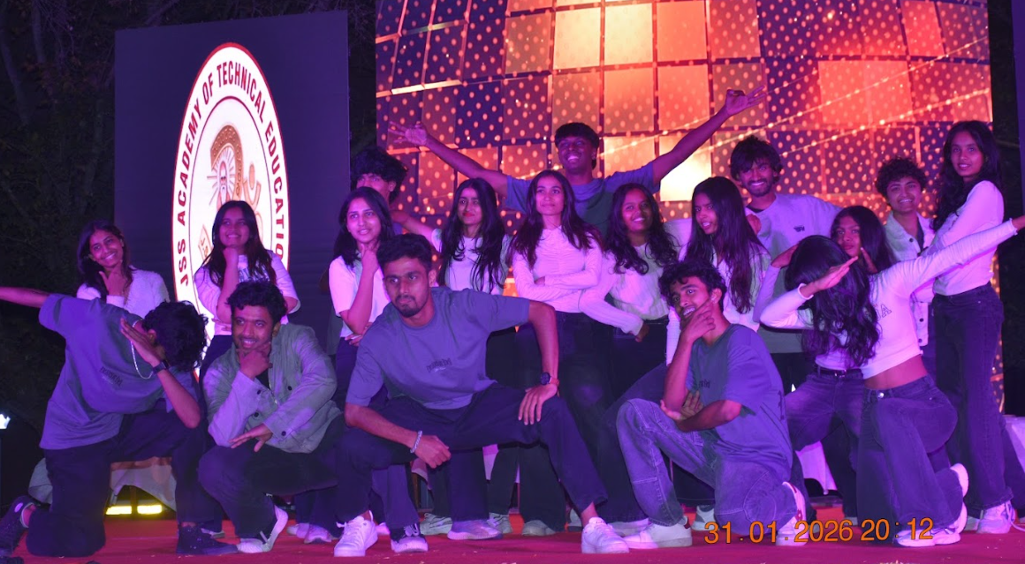 |  | 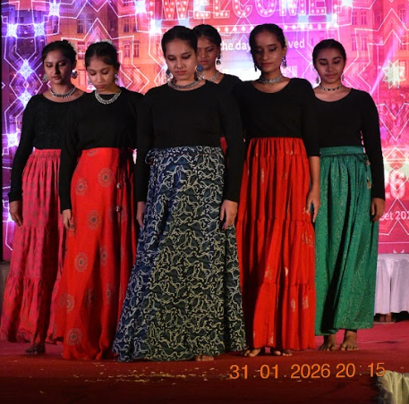
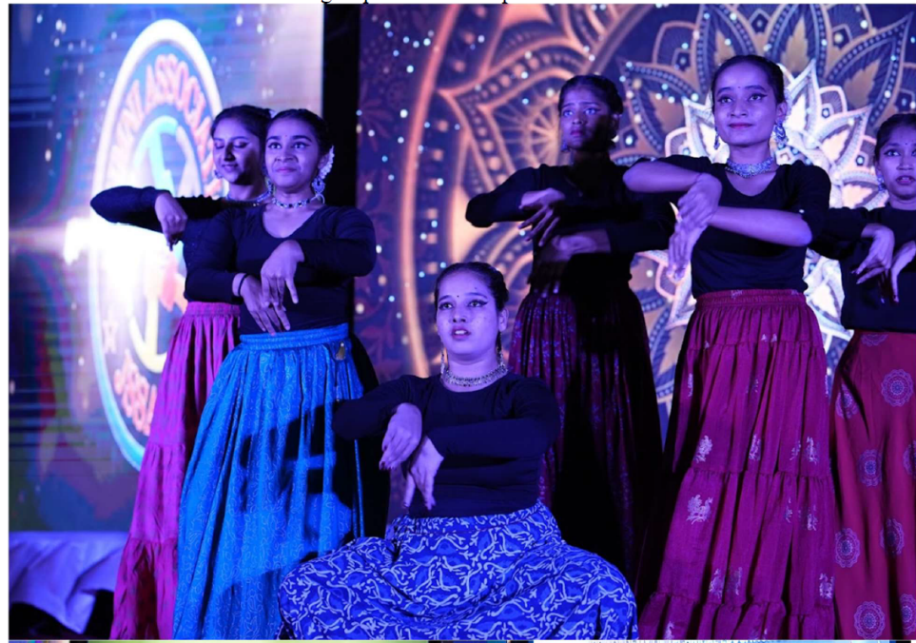
Cultural Events by Students
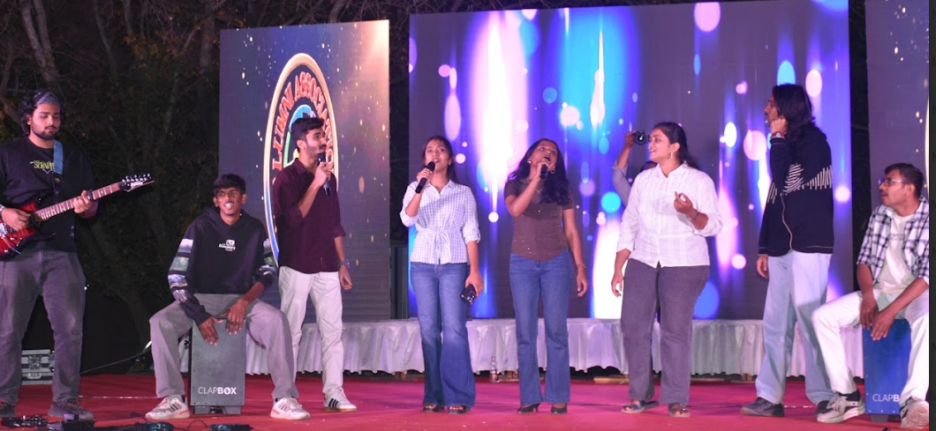
Musical Event by students
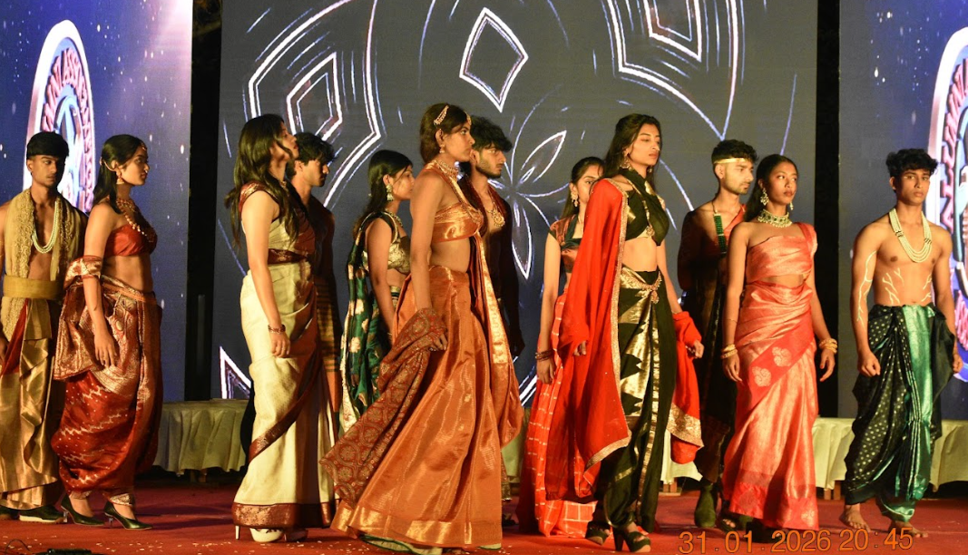
Fashion Show by Students
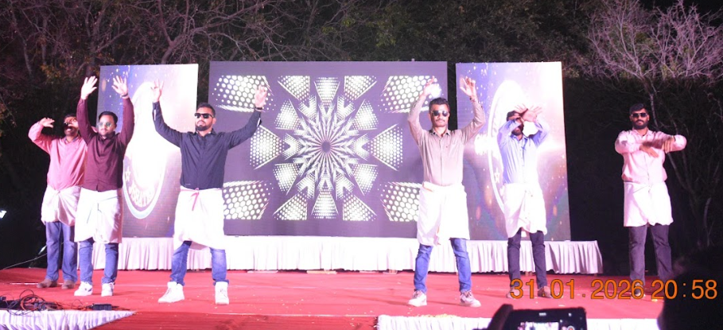

Cultural Event by Staff
Global Alumni Meet 2026-Invitation

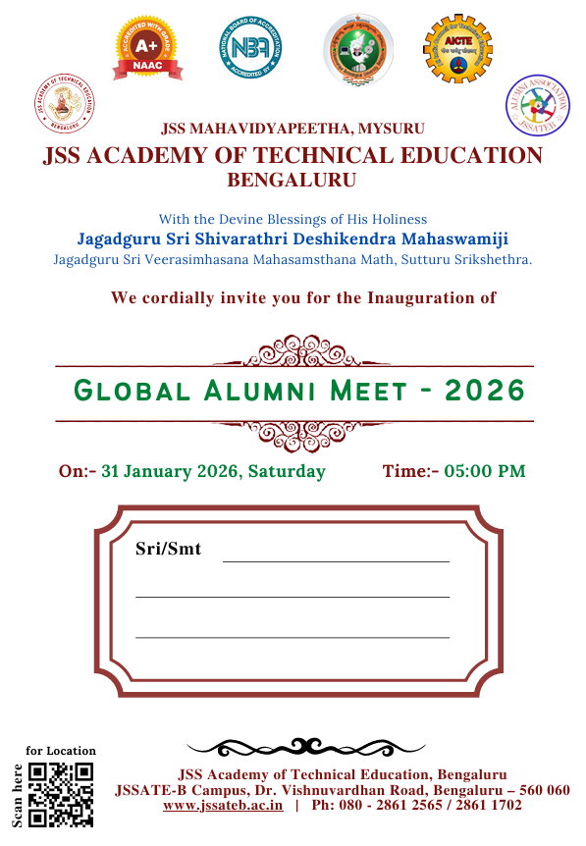 |  |  | 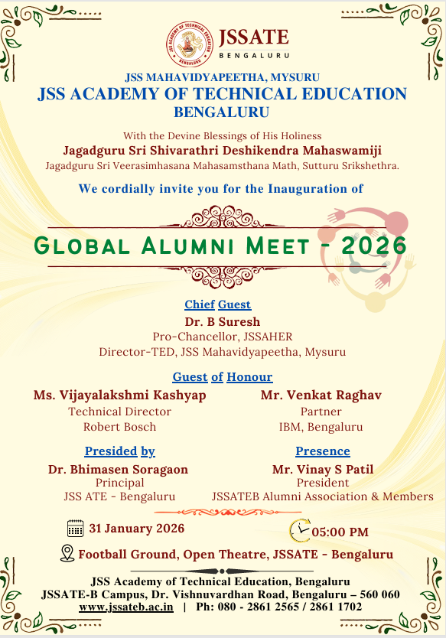
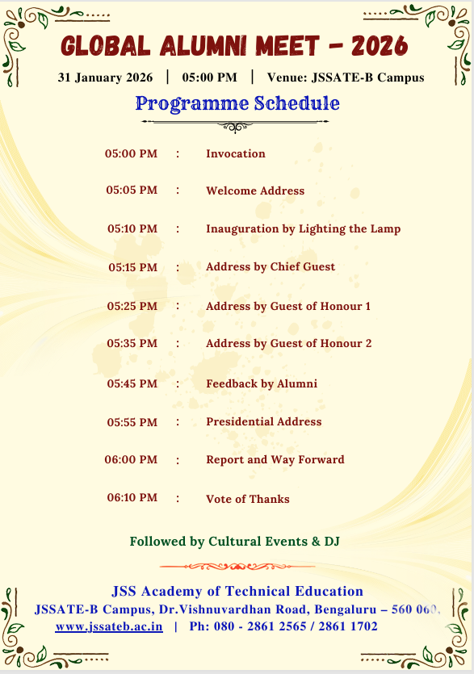

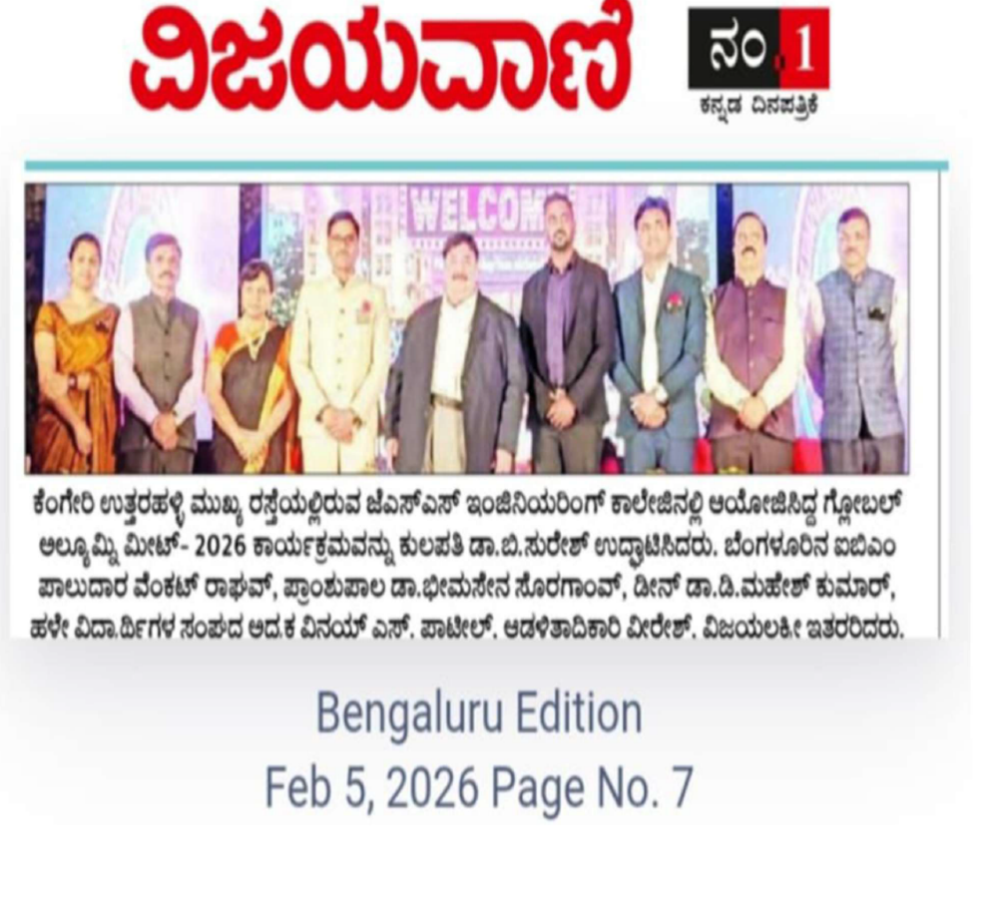

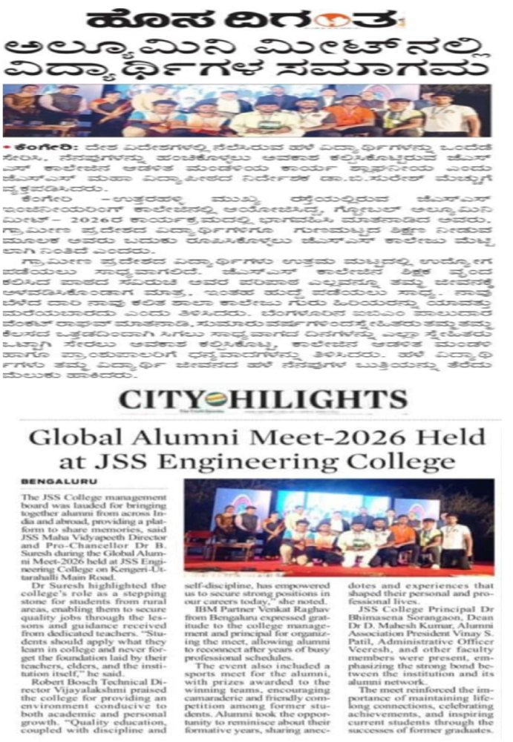
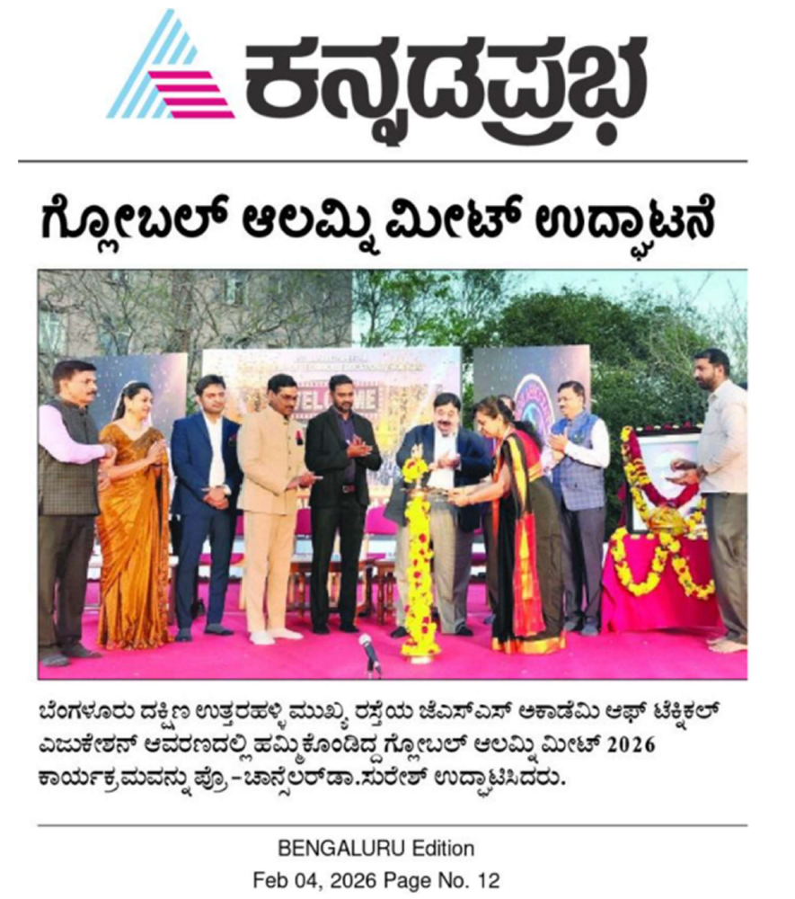

Signature of Coordinator Signature of Principal

